Historian migration

Error queue movement from _ERROR_QUEUE to _INTERMEDTIATE_QUEUE_

* Login into Active mq server 10.228.145.117 from east bastian

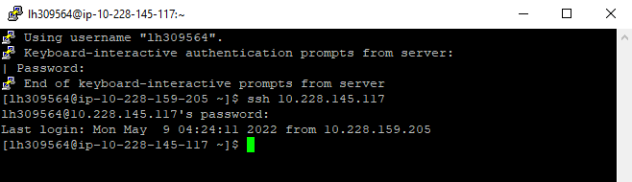

* Switch to root user :- sudo su

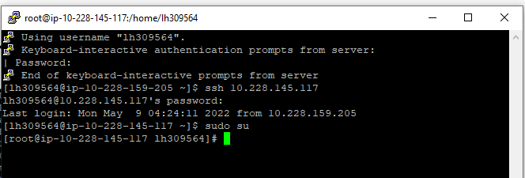

* Move into active mq Root directory
* cd /mnt/apache-activemq-5.14.0/bin
* ./activemq browse --amqurl tcp://localhost:61616 *_Intermediate_Error_Queue >

*_Intermediate_Error_Queue.txt

* aws s3 cp *_Intermediate_Error_Queue.txt s3://ge-engineering/vamsheetest/queues/
* now login into s3 bucket in above path we can see the uploaded file

ssh into 10.228.156.50 --- for insert messages and final parqet same server we use

in this process we are just using now for message insertion